WEEK 03- PCA MACHINE LEARNING ALGORITHM
What is Principal Component Analysis (PCA)?
PCA, or Principal component analysis, is the main linear algorithm for dimension reduction often used in unsupervised learning. In simple words, PCA tries to reduce the number of dimension whilst retaining as much variation in the data as possible.
This algorithm identifies and discards features that are less useful to make a valid approximation on a dataset.
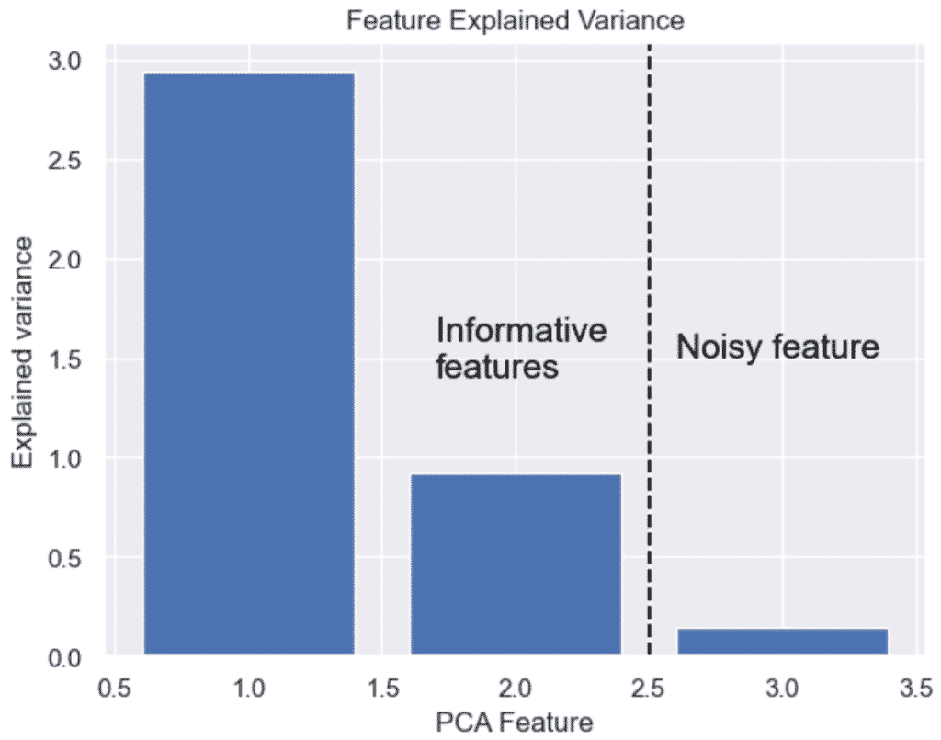
Introduction to PCA in Python
Principal Component Analysis (PCA) is a technique used in Python and machine learning to reduce the dimensionality of high-dimensional data while preserving the most important information.
Simply put, PCA makes complex data simpler by taking a lot of information and finding the most important parts. This helps to fight the curse of dimensionality.
Install Scikit-Learn to use PCA in Python
For this tutorial, you will also need to install Python and install Scikit-learn library from your command prompt or Terminal.
$ pip install scikit-learn
Simplest Example of PCA in Python
Here is a simple example of how to use Python PCA algorithm in Scikit-learn to reduce the features of the Iris dataset and plot a 2D graph.

import matplotlib.pyplot as plt
from sklearn.decomposition import PCA
from sklearn.datasets import load_iris

# Load Iris dataset
iris = load_iris()
X = iris.data
y = iris.target

# Apply PCA with two components (for 2D visualization)
pca = PCA(n_components=2)
X_pca = pca.fit_transform(X)

# Plot the results
plt.scatter(X_pca[:, 0], X_pca[:, 1], c=y, cmap='viridis', edgecolor='k')
plt.title('PCA of Iris Dataset')
plt.xlabel('Principal Component 1')
plt.ylabel('Principal Component 2')
plt.show()
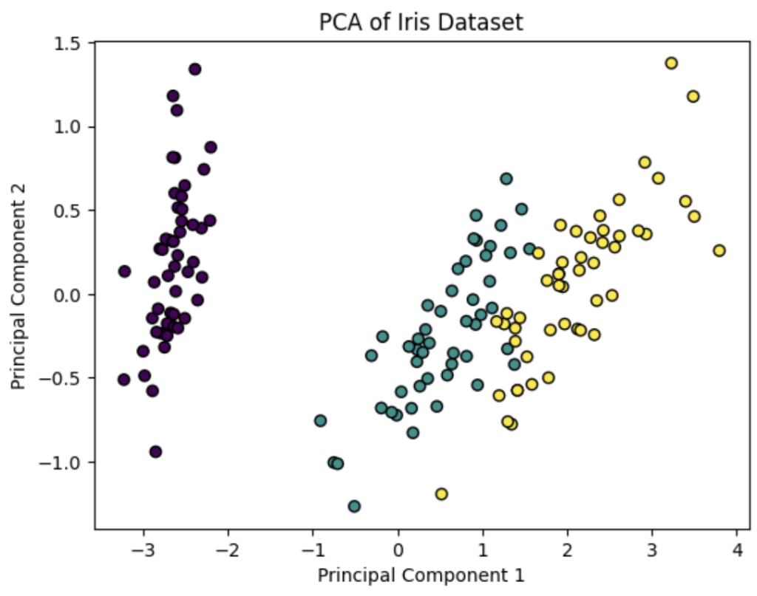
Getting Started with Principal Component Analysis in Python
In this Python tutorial, we will perform principal component analysis on the Iris dataset using Scikit-learn. We will now install Scikit-learn and load the built-in Iris dataset.
- Explore the Iris Dataset
- Load the Dataset with Sciki-learn
- Perform Data Preprocessing in Python
- Perform Dimension Reduction using PCA in Python
- Give Names for Your Plot by Mapping targets to Principal Components
- Plot the 2D PCA Graph
1. Explore the Python Dataset (Iris)
The Iris dataset is useful to visualize how Principal Component Analysis works.
The iris dataset contains 4 features (predictor variables) describing 3 species of flowers (targets).
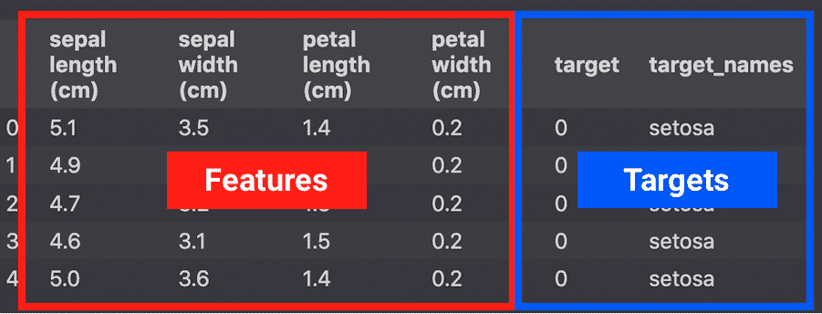source: iris dataset in pandas
2. Load the Iris Dataset with Scikit-Learn
To load the Iris dataset from Scikit-learn, let’s load features and targets as arrays stored in their respective X and y variables.
1  2  3  4  5  6 | from sklearn import datasets  # load features and targets separately  iris = datasets.load_iris()  X = iris.data  y = iris.target
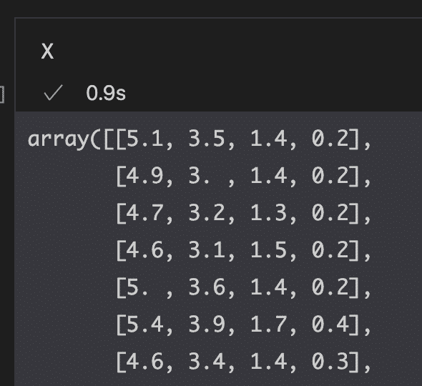
3. Perform Data Preprocessing in Python
Before running PCA, let’s perform very basic data preprocessing and scale the data using StandardScaler.
1  2  3 | # data scaling  from sklearn.preprocessing import StandardScaler  x_scaled = StandardScaler().fit_transform(X)
StandardScaler will standardize the features by removing the mean and scaling to unit variance so that each feature has μ = 0 and σ = 1.
Converting this:
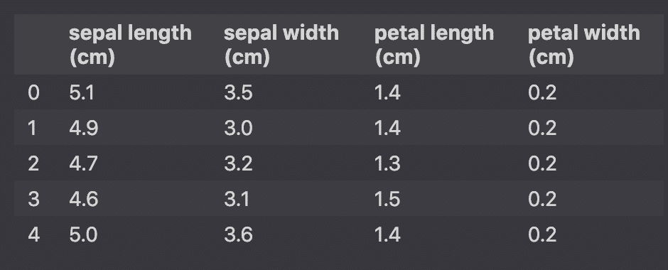
Unscaled features Into this:
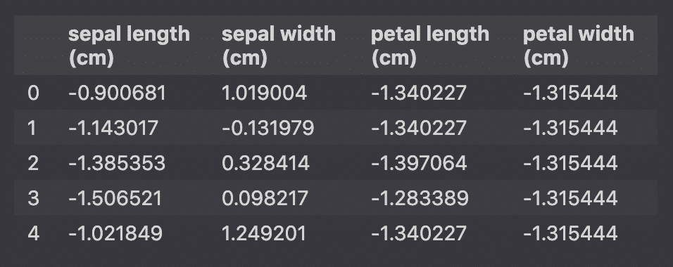Scaled features
4. Perform Dimension Reduction using PCA in Python
To perform dimension reduction in Python, import PCA from sklearn.decomposition and use the fit_transform() method on the PCA() object. The n_components argument tells the number of dimensions to keep.
We have seen that the Iris dataset contains 4 features, making it a 4-dimensional dataset. Not all features are necessarily useful for the prediction. Therefore, we can remove those noisy features and make a faster model.
The n_components argument will define the number of components that we want to reduce the features to.
1  2  3  4  5  6  7 | # Dimention Reduction  pca = PCA(n_components=2)  pca_features = pca.fit_transform(x_scaled)  # Show PCA characteristics  print('Shape before PCA: ', x_scaled.shape)  print('Shape after PCA: ', pca_features.shape)
Shape before PCA: (150, 4)
Shape after PCA: (150, 2)
For better understanding, PCA converted this data with 4 features.
Into this data with 2 principal components.
1  2  3  4  5  6  7 | # Create PCA DataFrame  pca_df = pd.DataFrame(  data=pca_features,  columns=[  'Principal Component 1',  'Principal Component 2'  ]
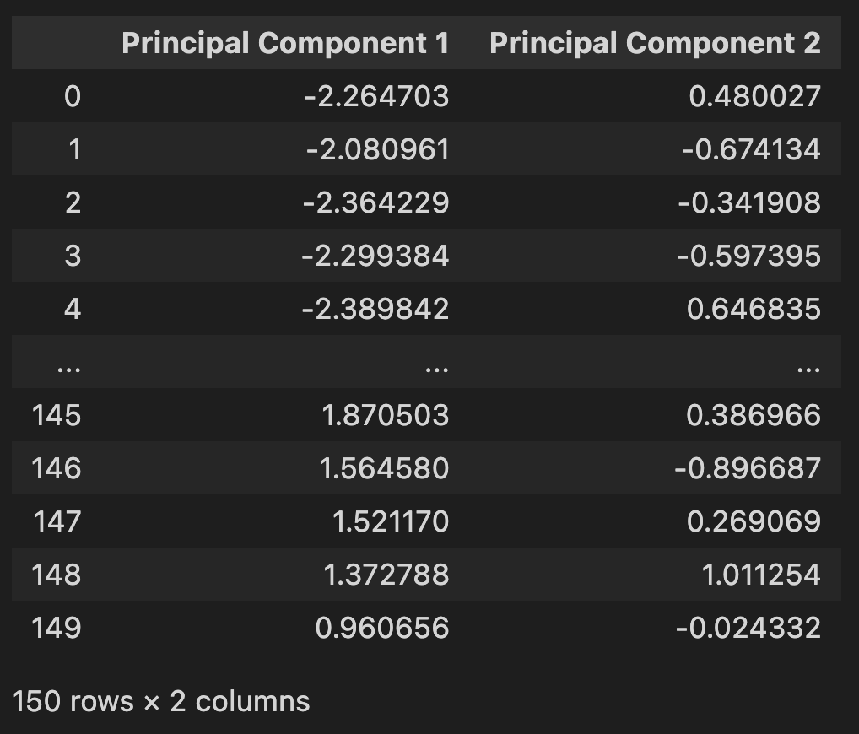
5. Give Names for Your Plot by Mapping targets to Principal Components
We will prepare the PCA Dataframe for visualization by mapping the target names to the PCA features.
1  2  3  4  5  6  7  8  9  10 | # Map target names to targets  target_names = {  0:'setosa',  1:'versicolor',  2:'virginica'  }  pca_df['target'] = y  pca_df['target'] = pca_df['target'].map(target_names)  pca_df.sample(10)
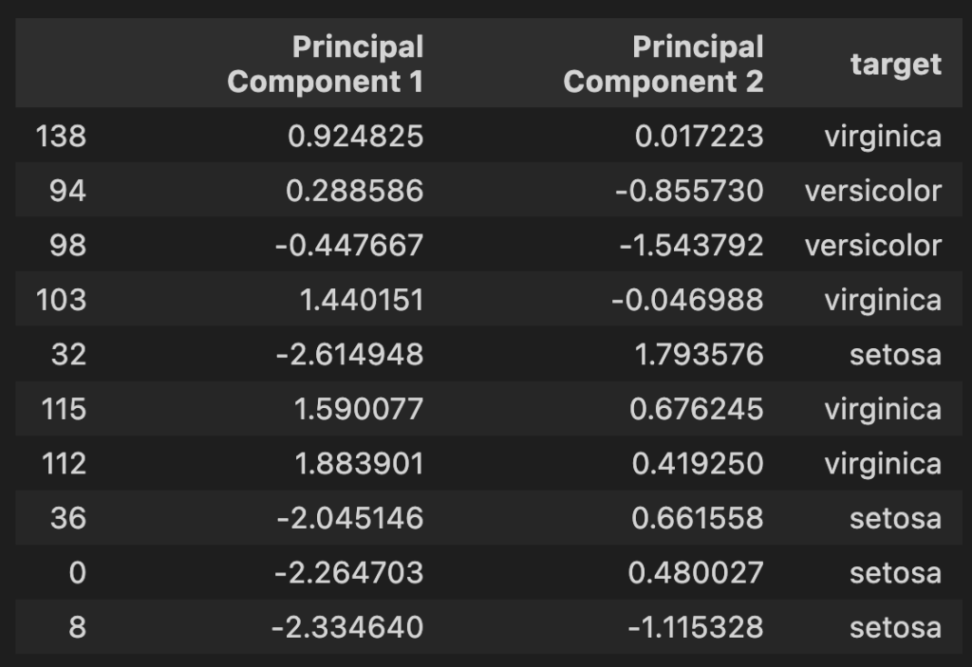
6. Plot the 2D PCA Graph
To plot the 2D PCA graph, use the Principal Component DataFrame to Seaborn’s lmplot() function.
1  2  3  4  5  6  7  8  9  10  11  12  13  14  15 | import matplotlib.pyplot as plt  import seaborn as sns  sns.set()  # Plot 2D PCA Graph  sns.lmplot(  x='Principal Component 1',  y='Principal Component 2',  data=pca_df,  hue='target',  fit_reg=False,  legend=True  )  plt.title('2D PCA Graph of Iris Dataset')  plt.show()
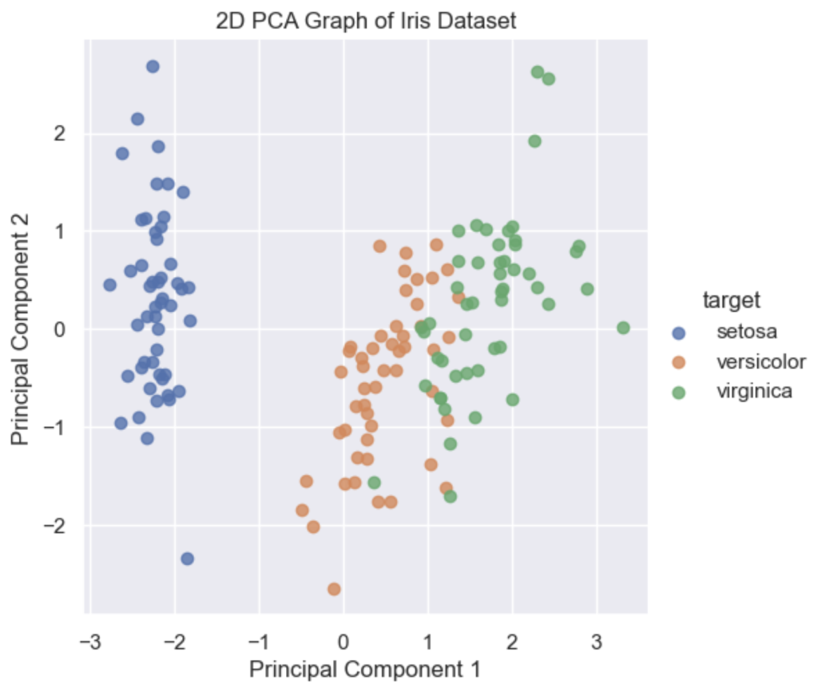
How Many Dimensions Should You Reduce Your Data with PCA?
To decide the number of dimensions that you should reduce your data to, you should make a cumulative explained variance plot (scree plot) to show each of your individual component variance on top of your cumulative variance.
We could decide to keep 90%+ of the variance and thus keep 3 Principal components.
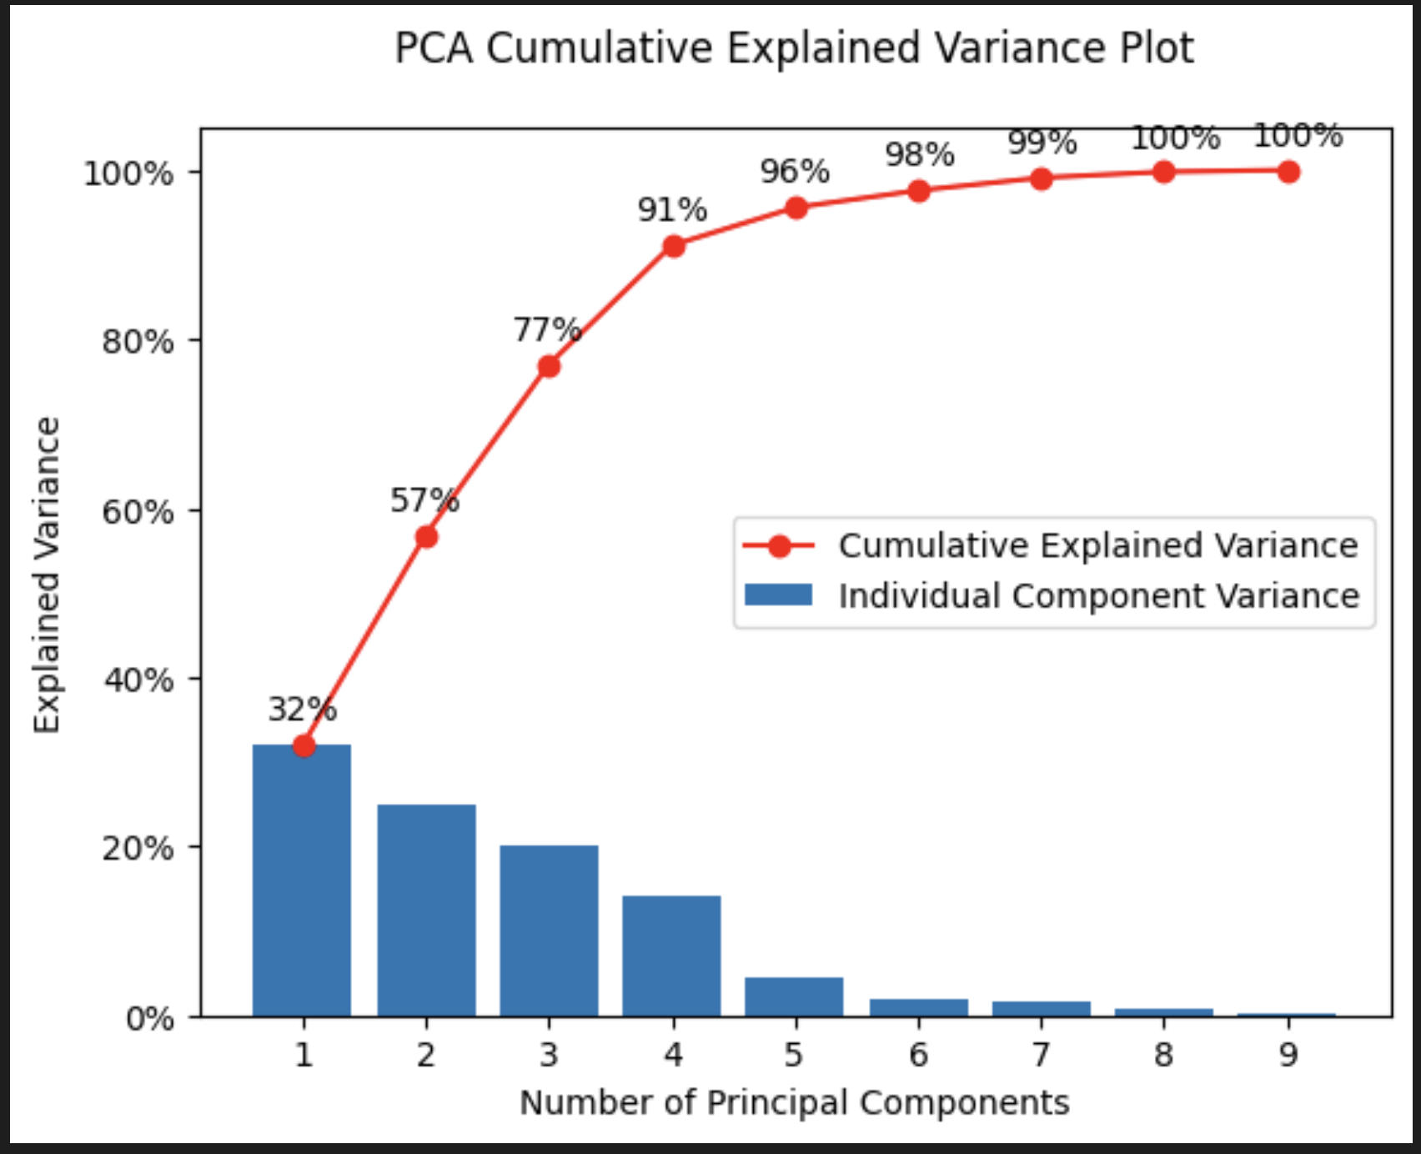
Full PCA Code
1  2  3  4  5  6  7  8  9  10  11  12  13  14  15  16  17  18  19  20  21  22  23  24  25  26  27  28  29  30  31  32  33  34  35  36  37  38  39  40  41  42  43  44  45  46  47  48  49  50  51  52  53  54  55  56  57  58  59  60  61  62  63  64  65  66  67  68  69 | import pandas as pd  from sklearn import datasets  from sklearn.preprocessing import StandardScaler  from sklearn.decomposition import PCA  import matplotlib.pyplot as plt  import seaborn as sns  sns.set()  # load features and targets separately  iris = datasets.load_iris()  X = iris.data  y = iris.target  # Data Scaling  x_scaled = StandardScaler().fit_transform(X)  # Dimention Reduction  pca = PCA(n_components=2)  pca_features = pca.fit_transform(x_scaled)  # Show PCA characteristics  print('Shape before PCA: ', x_scaled.shape)  print('Shape after PCA: ', pca_features.shape)  print('PCA Explained variance:', pca.explained_variance_)  # Create PCA DataFrame  pca_df = pd.DataFrame(  data=pca_features,  columns=[  'Principal Component 1',  'Principal Component 2'  ])  # Map target names to targets  target_names = {  0:'setosa',  1:'versicolor',  2:'virginica'  }  pca_df['target'] = y  pca_df['target'] = pca_df['target'].map(target_names)  pca_df.sample(10)  # Plot 2D PCA Graph  sns.lmplot(  x='Principal Component 1',  y='Principal Component 2',  data=pca_df,  hue='target',  fit_reg=False,  legend=True  )  plt.title('2D PCA Graph of Iris Dataset')  plt.show()  # Bar plot of explained_variance  plt.bar(  range(1,len(pca.explained_variance_)+1),  pca.explained_variance_  )  plt.xlabel('PCA Feature')  plt.ylabel('Explained variance')  plt.title('Feature Explained Variance')  plt.show()

Exercises
Q-Use IRIS data set plot the 6 Best PCA Plots & Visualizations with Python such as
- Feature Explained Variance Bar Plot
- PCA Scree plot
- 2D PCA Scatter plot
- 3D PCA Scatter plot
- 2D PCA Biplot
- 3D PCA Biplot

